# Chameli Devi Group of Institutions

**Department of Artificial Intelligence and Data Science**

# AD 702 (A) Cloud Computing

# B. Tech VII Semester

# Unit -1

**………………………………………………………………………………………………………………… …………………………………………….**

**Syllabus: Introduction To Cloud Computing:** Definition, Characteristics, Components, Cloud

Architecture: Software as a Service, Plat form as a Service, Infrastructure as Service. Cloud deployment model: Public clouds–Private clouds–Community clouds-Hybrid clouds- Advantages of Cloud computing. Comparing cloud providers with traditional IT service providers**.**

**…………………………………………………………………………………………………………………………………………….**

### ****Definition of Cloud Computing****

Cloud computing is the delivery of various services over the internet, including storage, databases, servers, networking, software, and analytics. Instead of owning and managing physical servers and infrastructure, users can rent access to these resources from cloud service providers.

**Cloud Computing** means storing and accessing the data and programs on remote servers that are hosted on the internet instead of the computer’s hard drive or local server. Cloud computing is also referred to as Internet-based computing, it is a technology where the resource is provided as a service through the Internet to the user. The data that is stored can be files, images, documents, or any other storable document.

**Key Points:**

* **On-Demand Access:** Users can access computing resources whenever needed.
* **Internet-Based:** Services are delivered via the internet.
* **Pay-as-You-Go:** Users pay only for the resources they use.

## Why Cloud Computing?

Small as well as large IT companies, follow the traditional methods to provide the IT infrastructure. That means **for any IT company, we need a Server Room that is the basic need of IT companies**.

In that server room, there should be a database server, mail server, networking, firewalls, routers, modem, switches, QPS (Query Per Second means how much queries or load will be handled by the server), configurable system, high net speed, and the maintenance engineers.

To establish such IT infrastructure, we need to spend lots of money. To overcome all these problems and to reduce the IT infrastructure cost, Cloud Computing comes into existence.

* 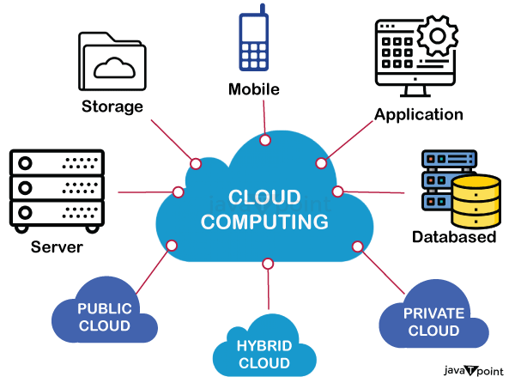

### ****2. Characteristics of Cloud Computing****

1. **On-Demand Self-Service:**
   * Users can provision computing capabilities such as server time and network storage automatically without requiring human intervention from the service provider.
   * **Example:** Provisioning a virtual server from AWS EC2 via the AWS Management Console.
2. **Broad Network Access:**
   * Services are accessible over the network through standard mechanisms (e.g., web browsers) and from a variety of devices (e.g., smartphones, laptops).
   * **Example:** Accessing Google Docs from a mobile device or desktop computer.
3. **Resource Pooling:**
   * Cloud providers use multi-tenant models to pool computing resources. These resources are dynamically assigned and reassigned based on demand.
   * **Example:** AWS uses a single pool of servers to provide resources to multiple users.
4. **Rapid Elasticity:**
   * Resources can be rapidly and elastically provisioned to scale outward or inward according to demand. This means that if demand increases, additional resources can be allocated quickly.
   * **Example:** Automatically scaling web server instances up or down based on website traffic using AWS Auto Scaling.
5. **Measured Service:**
   * Cloud computing systems automatically control and optimize resource use by leveraging a metering capability. This allows for resource usage monitoring, control, and reporting.
   * **Example:** Billing is based on the amount of storage used or the number of virtual machines running.

## Components of Cloud Computing Architecture

Following are the components of Cloud Computing Architecture

1. **Client Infrastructure –** Client Infrastructure is a part of the frontend component. It contains the applications and user interfaces which are required to access the cloud platform. In other words, it provides a GUI( Graphical User Interface ) to interact with the cloud.
2. **Application** : Application is a part of backend component that refers to a software or platform to which client accesses. Means it provides the service in backend as per the client requirement.
3. **Service**: Service in backend refers to the major three types of cloud based services like SaaS, PaaS and IaaS. Also manages which type of service the user accesses.
4. **Runtime Cloud**: Runtime cloud in backend provides the execution and Runtime platform/environment to the Virtual machine.
5. **Storage:** Storage in backend provides flexible and scalable storage service and management of stored data.
6. **Infrastructure:** Cloud Infrastructure in backend refers to the hardware and software components of cloud like it includes servers, storage, network devices, virtualization software etc.
7. **Management:** Management in backend refers to management of backend components like application, service, runtime cloud, storage, infrastructure, and other security mechanisms etc.
8. **Security:** Security in backend refers to implementation of different security mechanisms in the backend for secure cloud resources, systems, files, and infrastructure to end-users.
9. **Internet:** Internet connection acts as the medium or a bridge between frontend and backend and establishes the interaction and communication between frontend and backend.
10. **Database:** Database in backend refers to provide database for storing structured data, such as SQL and NOSQL databases. Example of Databases services include Amazon RDS, Microsoft Azure SQL database and Google CLoud SQL.
11. **Networking:** Networking in backend services that provide networking infrastructure for application in the cloud, such as load balancing, DNS and virtual private networks.
12. **Analytics:** Analytics in backend service that provides analytics capabilities for data in the cloud, such as warehousing, business intelligence and machine learning.

### ****4. Cloud Architecture****

Cloud computing technology is used by both small and large organizations to **store the information** in cloud and **access** it from anywhere at anytime using the internet connection.

Cloud computing architecture is a combination of **service-oriented architecture** and **event-driven architecture**.

Cloud computing architecture is divided into the following two parts –

* Front End
* Back End

The below diagram shows the architecture of cloud computing -

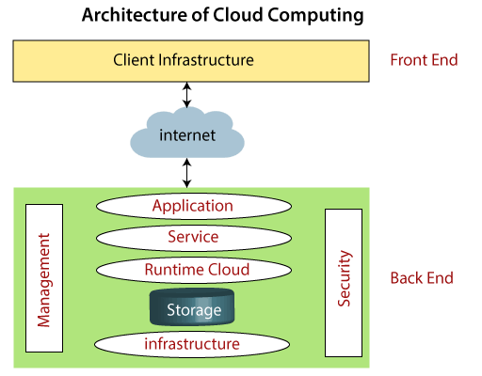

### Front End

The front end is used by the client. It contains client-side interfaces and applications that are required to access the cloud computing platforms. The front end includes web servers (including Chrome, Firefox, internet explorer, etc.), thin & fat clients, tablets, and mobile devices.

### Back End

The back end is used by the service provider. It manages all the resources that are required to provide cloud computing services. It includes a huge amount of data storage, security mechanism, virtual machines, deploying models, servers, traffic control mechanisms, etc.

1. **Software as a Service (SaaS):**
   * **Definition:** SaaS delivers applications over the internet. Users access these applications via web browsers, and the provider manages the underlying infrastructure and platform.

Software As A Service (SAAS) allows users to run existing online applications and it is a model software that is deployed as a hosting service and is accessed over Output Rephrased/Re-written Text the internet or software delivery model during which software and its associated data are hosted centrally and accessed using their client, usually an online browser over the web. SAAS services are used for the development and deployment of modern applications.

It allows software and its functions to be accessed from anywhere with good internet connection device and a browser. An application is hosted centrally and also provides access to multiple users across various locations via the internet.

### Characteristics of SAAS (Software ****as a Service****)

* Applications are ready to use, and updates and maintenance are handled by the provider.
* You access the software through a web browser or app, usually paying a subscription fee.
* It’s convenient and requires minimal technical expertise, ideal for non-technical users.

### Example of SAAS (Software as a Service)

* Salesforce
* Google Workspace apps
* Microsoft 365
* Trello
* Zoom
* Slack
* Adobe Creative Cloud

1. **Platform as a Service (PaaS):**
   * **Definition:** PaaS provides a platform that allows developers to build, deploy, and manage applications without dealing with the underlying infrastructure.

Platform As A Service (PAAS) is a cloud delivery model for applications composed of services managed by a third party. It provides elastic scaling of your application which allows developers to build applications and services over the internet and the deployment models include public, private and hybrid.

Basically, it is a service where a third-party provider provides both software and hardware tools to the cloud computing. The tools which are provided are used by developers. PAAS is also known as Application PAAS. It helps us to organize and maintain useful applications and services. It has a well-equipped management system and is less expensive compared to IAAS.

### Characteristics of PAAS (****Platform as a Service****)

* PAAS is like a toolkit for developers to build and deploy applications without worrying about infrastructure.
* Provides pre-built tools, libraries, and development environments.
* Developers focus on building and managing applications, while the provider handles infrastructure management.
* It speeds up the development process and allows for easy collaboration among developers.

### Examples of PAAS (Platform as a Service)

* AWS Lambda
* Google App Engine
* Google Cloud
* IBM Cloud

1. **Infrastructure as a Service (IaaS):**
   * **Definition:** IaaS provides virtualized computing resources over the internet. Users can rent virtual servers, storage, and networking capabilities.

Infrastructure As A Service (IAAS) is means of delivering computing infrastructure as on-demand services. It is one of the three fundamental cloud service models. The user purchases servers, software data center space, or network equipment and rent those resources through a fully outsourced, on-demand service model. It allows dynamic scaling and the resources are distributed as a service. It generally includes multiple-user on a single piece of hardware.

It totally depends upon the customer to choose its resources wisely and as per need. Also, it provides billing management too.

### Characteristics of IAAS (****Infrastructure as a Service****)

* IAAS is like renting virtual computers and storage space in the cloud.
* You have control over the operating systems, applications, and development frameworks.
* Scaling resources up or down is easy based on your needs.

### Example of IAAS (Infrastructure As A Service)

* Amazon Web Services
* Microsoft Azure
* Google Compute Engine
* Digital Ocean

### ****Cloud Deployment Models****

The cloud deployment model identifies the specific type of cloud environment based on ownership, scale, and access, as well as the cloud’s nature and purpose. The location of the servers you’re utilizing and who controls them are defined by a cloud deployment model. It specifies how your cloud infrastructure will look, what you can change, and whether you will be given services or will have to create everything yourself. Relationships between the infrastructure and your users are also defined by cloud deployment types. Different types of cloud computing deployment models are described below.

* Public Cloud
* Private Cloud
* Hybrid Cloud
* Community Cloud
* Multi-Cloud

### ****Public Cloud****

The public cloud makes it possible for anybody to access systems and services. The public cloud may be less secure as it is open to everyone. The public cloud is one in which cloud infrastructure services are provided over the internet to the general people or major industry groups. The infrastructure in this cloud model is owned by the entity that delivers the cloud services, not by the consumer.

It is a type of cloud hosting that allows customers and users to easily access systems and services. This form of cloud computing is an excellent example of cloud hosting, in which service providers supply services to a variety of customers. In this arrangement, storage backup and retrieval services are given for free, as a subscription, or on a per-user basis. For example, Google App Engine etc.

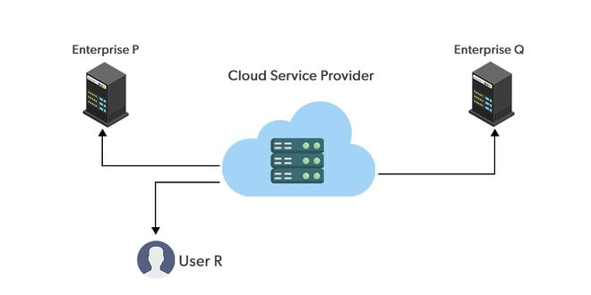

#### ****Advantages of the Public Cloud Model****

* **Minimal Investment:** Because it is a pay-per-use service, there is no substantial upfront fee, making it excellent for enterprises that require immediate access to resources.
* **No setup cost:** The entire infrastructure is fully subsidized by the cloud service providers, thus there is no need to set up any hardware.
* **Infrastructure Management is not required:** Using the public cloud does not necessitate infrastructure management.
* **No maintenance:** The maintenance work is done by the service provider (not users).
* **Dynamic Scalability:** To fulfill your company’s needs, on-demand resources are accessible.

#### ****Disadvantages of the Public Cloud Model****

* **Less secure:** Public cloud is less secure as resources are public so there is no guarantee of high-level security.
* **Low customization:** It is accessed by many public so it can’t be customized according to personal requirements.

### ****Private Cloud****

The private cloud deployment model is the exact opposite of the public cloud deployment model. It’s a one-on-one environment for a single user (customer). There is no need to share your hardware with anyone else. The distinction between [private and public clouds](https://www.geeksforgeeks.org/difference-between-public-cloud-and-private-cloud/) is in how you handle all of the hardware. It is also called the “internal cloud” & it refers to the ability to access systems and services within a given border or organization. The cloud platform is implemented in a cloud-based secure environment that is protected by powerful firewalls and under the supervision of an organization’s IT department. The private cloud gives greater flexibility of control over cloud resources.

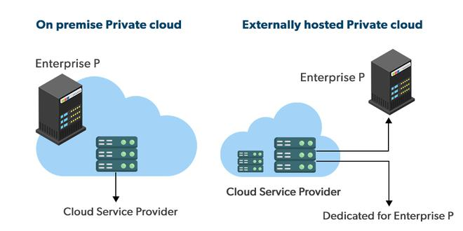

#### ****Advantages of the Private Cloud Model****

* **Better Control:** You are the sole owner of the property. You gain complete command over service integration, IT operations, policies, and user behavior.
* **Data Security and Privacy:** It’s suitable for storing corporate information to which only authorized staff have access. By segmenting resources within the same infrastructure, improved access and security can be achieved.
* **Supports Legacy Systems:** This approach is designed to work with legacy systems that are unable to access the public cloud.
* **Customization:** Unlike a public cloud deployment, a private cloud allows a company to tailor its solution to meet its specific needs.

#### ****Disadvantages of the Private Cloud Model****

* **Less scalable:** Private clouds are scaled within a certain range as there is less number of clients.
* **Costly:** Private clouds are more costly as they provide personalized facilities.

### ****Hybrid Cloud****

By bridging the public and private worlds with a layer of proprietary software, hybrid cloud computing gives the best of both worlds. With a hybrid solution, you may host the app in a safe environment while taking advantage of the public cloud’s cost savings. Organizations can move data and applications between different clouds using a combination of two or more cloud deployment methods, depending on their needs.

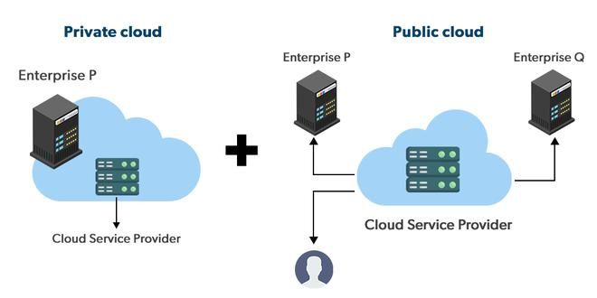

#### ****Advantages of the Hybrid Cloud Model****

* **Flexibility and control:** Businesses with more flexibility can design personalized solutions that meet their particular needs.
* **Cost:** Because public clouds provide scalability, you’ll only be responsible for paying for the extra capacity if you require it.
* **Security:** Because data is properly separated, the chances of data theft by attackers are considerably reduced.

#### ****Disadvantages of the Hybrid Cloud Model****

* **Difficult to manage:** Hybrid clouds are difficult to manage as it is a combination of both public and private cloud. So, it is complex.
* **Slow data transmission:** Data transmission in the hybrid cloud takes place through the public cloud so latency occurs.

### ****Community Cloud****

It allows systems and services to be accessible by a group of organizations. It is a distributed system that is created by integrating the services of different clouds to address the specific needs of a community, industry, or business. The infrastructure of the community could be shared between the organization which has shared concerns or tasks. It is generally managed by a third party or by the combination of one or more organizations in the community.

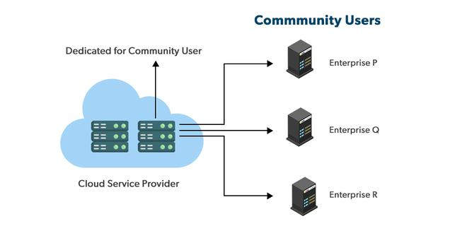

#### ****Advantages of the Community Cloud Model****

* **Cost Effective:** It is cost-effectivebecause the cloud is shared by multiple organizations or communities.
* **Security:** Community cloud provides better security.
* **Shared resources:** It allows you to share resources, infrastructure, etc. with multiple organizations.
* **Collaboration and data sharing:** It is suitable for both collaboration and data sharing.

#### ****Disadvantages of the Community Cloud Model****

* **Limited Scalability:** Community cloud is relatively less scalable as many organizations share the same resources according to their collaborative interests.
* **Rigid in customization:** As the data and resources are shared among different organizations according to their mutual interests if an organization wants some changes according to their needs they cannot do so because it will have an impact on other organizations.

### ****Multi-Cloud****

We’re talking about employing [multiple cloud providers](https://www.geeksforgeeks.org/overview-of-multi-cloud/) at the same time under this paradigm, as the name implies. It’s similar to the hybrid cloud deployment approach, which combines public and private cloud resources. Instead of merging private and public clouds, multi-cloud uses many public clouds. Although public cloud providers provide numerous tools to improve the reliability of their services, mishaps still occur. It’s quite rare that two distinct clouds would have an incident at the same moment. As a result, multi-cloud deployment improves the high availability of your services even more.

#### ****Advantages of the Multi-Cloud Model****

* You can mix and match the best features of each cloud provider’s services to suit the demands of your apps, workloads, and business by choosing different cloud providers.
* **Reduced Latency:** To reduce latency and improve user experience, you can choose cloud regions and zones that are close to your clients.
* **High availability of service:** It’s quite rare that two distinct clouds would have an incident at the same moment. So, the multi-cloud deployment improves the high availability of your services.

#### ****Disadvantages of the Multi-Cloud Model****

* **Complex:** The combination of many clouds makes the system complex and bottlenecks may occur.
* **Security issue:** Due to the complex structure, there may be loopholes to which a hacker can take advantage hence, makes the data insecure.

### ****6. Advantages of Cloud Computing****

1. **Cost Efficiency:**
   * Reduces capital expenditures by eliminating the need for physical hardware and data centers. Users pay only for the resources they use.
2. **Scalability:**
   * Easily scale resources up or down based on current needs. This is beneficial for handling varying workloads and seasonal demands.
3. **Performance:**
   * High-performance computing environments are provided by cloud providers, utilizing state-of-the-art hardware and data centers.
4. **Accessibility:**
   * Access services and data from anywhere with an internet connection, supporting remote work and global operations.
5. **Disaster Recovery:**
   * Provides robust disaster recovery options, including data backup, redundancy, and failover solutions.
6. **Automatic Updates:**
   * Cloud providers manage and deploy updates and patches automatically, ensuring systems are up-to-date with the latest features and security enhancements.

**Coparing Cloud Providers with Traditional IT Service Providers**

## ****What is Traditional Computing?****

Traditional Computing, as name suggests, is a possess of using physical data centers for storing digital assets and running complete networking system for daily operations. In this, access to data, or software, or storage by users is limited to device or official network they are connected with. In this computing, user can have access to data only on system in which data is stored.

| **Aspect** | **Cloud Computing** | **Traditional Computing** |
| --- | --- | --- |
| **Definition** | Cloud Computing refers to delivery of different services such as data and programs through internet on different servers. | Traditional Computing refers to delivery of different services on local server. |
| **Infrastructure Location** | Cloud Computing takes place on third-party servers that is hosted by third-party hosting companies. | Traditional Computing takes place on physical hard drives and website servers. |
| **Data Accessibility** | Cloud Computing is ability to access data anywhere at any time by user. | User can access data only on system in which data is stored. |
| **Cost Effectiveness** | Cloud Computing is more cost effective as compared to tradition computing as operation and maintenance of server is shared among several parties that in turn reduce cost of public services. | Traditional Computing is less cost effective as compared to cloud computing because one has to buy expensive equipment’s to operate and maintain server. |
| **User-Friendliness** | Cloud Computing is more user-friendly as compared to traditional computing because user can have access to data anytime anywhere using internet. | Traditional Computing is less user-friendly as compared to cloud computing because data cannot be accessed anywhere and if user has to access data in another system, then he need to save it in external storage medium. |
| **Internet Dependency** | Cloud Computing requires fast, reliable and stable internet connection to access information anywhere at any time. | Traditional Computing does not require any internet connection to access data or information. |
| **Storage and Computing Power** | Cloud Computing provides more storage space and servers as well as more computing power so that applications and software run must faster and effectively. | Traditional Computing provides less storage as compared to cloud computing. |
| **Scalability and Elasticity** | Cloud Computing also provides scalability and elasticity i.e., one can increase or decrease storage capacity, server resources, etc., according to business needs. | Traditional Computing does not provide any scalability and elasticity. |
| **Maintenance and Support** | Cloud service is served by provider’s support team. | Traditional Computing requires own team to maintain and monitor system that will need a lot of time and efforts. |
| **Software Delivery Model** | Software is offered as an on-demand service (SaaS) that can be accessed through subscription service. | Software in purchased individually for every user and requires to be updated periodically. |

**Comparing Cloud Providers with Traditional IT Service Providers**

1. **Cost Structure:**
   * **Cloud Providers:** Operate on a pay-as-you-go or subscription basis, reducing upfront capital costs and providing predictable expenses.
   * **Traditional IT:** Involves significant capital investment in hardware and software, with additional ongoing maintenance costs.
2. **Scalability:**
   * **Cloud Providers:** Offer on-demand scalability with the ability to rapidly adjust resources based on demand.
   * **Traditional IT:** Scaling requires additional hardware and infrastructure, which can be time-consuming and expensive.
3. **Management:**
   * **Cloud Providers:** Manage and maintain infrastructure, including security, updates, and backups, allowing organizations to focus on their core business activities.
   * **Traditional IT:** Requires internal resources to manage and maintain hardware and software, which can divert focus from core business operations.
4. **Deployment Time:**
   * **Cloud Providers:** Services and applications can be deployed quickly, often within minutes.
   * **Traditional IT:** Deployment can be lengthy due to the need to purchase, install, and configure hardware and software.
5. **Accessibility:**
   * **Cloud Providers:** Services are accessible from anywhere with an internet connection, supporting remote work and global collaboration.
   * **Traditional IT:** Access is often limited to on-premises environments or requires VPNs for remote access.
6. **Disaster Recovery:**
   * **Cloud Providers:** Typically offer built-in disaster recovery solutions and data redundancy as part of their service offerings.
   * **Traditional IT:** Disaster recovery solutions can be complex and costly, requiring additional infrastructure and management.

# Unit -II

**………………………………………………………………………………………………………………………………………………….. .Syllabus: Services Virtualization Technology and Study of Hypervisor:** Utility Computing,

Elastic computing & grid computing. Study of Hypervisor Virtualization applications in enterprises, High-performance computing, Pitfalls of virtualization Multitenant software: Multi-

entity support, Multi schema approach**.**

**……………………………………………………………………………………………………………………………………………………**

### ****Virtualization Technology Overview****

**Virtualization** is used to create a virtual version of an underlying service With the help of Virtualization, multiple operating systems and applications can run on the same machine and its same hardware at the same time, increasing the utilization and flexibility of hardware. It was initially developed during the mainframe era.

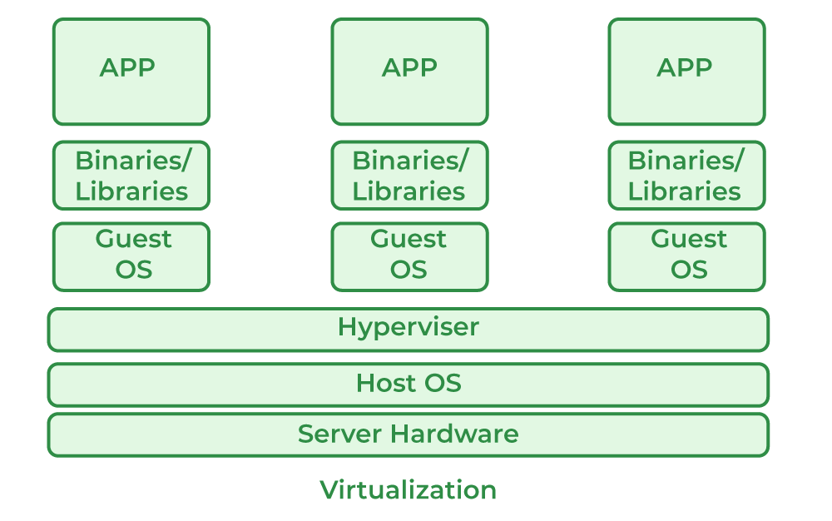

* Host Machine: The machine on which the virtual machine is going to be built is known as Host Machine.
* Guest Machine: The virtual machine is referred to as a Guest Machine.

Virtualization technology is a transformative approach in computing that allows multiple virtual environments or virtual machines (VMs) to operate on a single physical hardware system. By abstracting the hardware resources, virtualization creates isolated virtual instances, each capable of running its own operating system and applications. This abstraction is facilitated by a software layer known as the hypervisor, which manages the distribution of physical resources, such as CPU, memory, and storage, among the VMs. Virtualization enhances resource utilization, improves management efficiency, and provides a level of isolation that can bolster security and streamline testing and development processes.

## Uses of Virtualization

* Data-integration
* Business-integration
* Service-oriented architecture data-services
* Searching organizational data

## ****Benefits of Virtualization****

* More flexible and efficient allocation of resources.
* Enhance development productivity.
* It lowers the cost of IT infrastructure.
* Remote access and rapid scalability.
* High availability and disaster recovery.
* Pay peruse of the IT infrastructure on demand.
* Enables running multiple operating systems.

## Drawback of Virtualization

* **High Initial Investment:** Clouds have a very high initial investment, but it is also true that it will help in reducing the cost of companies.
* **Learning New Infrastructure:** As the companies shifted from Servers to Cloud, it requires highly skilled staff who have skills to work with the cloud easily, and for this, you have to hire new staff or provide training to current staff.
* **Risk of Data:** Hosting data on third-party resources can lead to putting the data at risk, it has the chance of getting attacked by any hacker or cracker very easily.

# What is a hypervisor

A hypervisor, also known as a virtual machine monitor or VMM. The hypervisor is a piece of software that allows us to build and run virtual machines which are abbreviated as VMs.

A hypervisor allows a single host computer to support multiple virtual machines (VMs) by sharing resources including memory and processing.

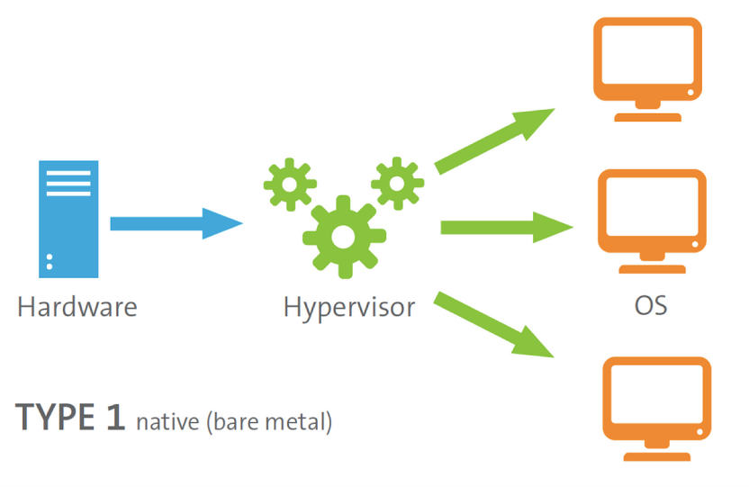

## What is the use of a hypervisor?

Hypervisors allow the use of more of a system's available resources and provide greater IT versatility because the guest VMs are independent of the host hardware which is one of the major benefits of the Hypervisor.

In other words, this implies that they can be quickly switched between servers. Since a hypervisor with the help of its special feature, it allows several virtual machines to operate on a single physical server. So, it helps us to reduce:

* The Space efficiency
* The Energy uses
* The Maintenance requirements of the server.

### ****Hypervisor Types****

There are two types of hypervisors: "Type 1" (also known as "bare metal") and "Type 2" (also known as "hosted"). A type 1 hypervisor functions as a light operating system that operates directly on the host's hardware, while a type 2 hypervisor functions as a software layer on top of an operating system, similar to other computer programs.

## The Type 1 hypervisor

The native or bare metal hypervisor, the Type 1 hypervisor is known by both names.

It replaces the host operating system, and the hypervisor schedules VM services directly to the hardware.

The type 1 hypervisor is very much commonly used in the enterprise data center or other server-based environments.

It includes KVM, Microsoft Hyper-V, and VMware vSphere. If we are running the updated version of the hypervisor then we must have already got the KVM integrated into the Linux kernel in 2007.

## The Type 2 hypervisor

It is also known as a hosted hypervisor, The type 2 hypervisor is a software layer or framework that runs on a traditional operating system.

It operates by separating the guest and host operating systems. The host operating system schedules VM services, which are then executed on the hardware.

Individual users who wish to operate multiple operating systems on a personal computer should use a form 2 hypervisor.

## What is a cloud hypervisor?

Hypervisors are a key component of the technology that enables cloud computing since they are a software layer that allows one host device to support several virtual machines at the same time.

Hypervisors allow IT to retain control over a cloud environment's infrastructure, processes, and sensitive data while making cloud-based applications accessible to users in a virtual environment.

Increased emphasis on creative applications is being driven by digital transformation and increasing consumer expectations. As a result, many businesses are transferring their virtual computers to the cloud.

### ****Utility Computing****

Utility computing is a service model in which computing resources are provided and billed based on actual usage, akin to traditional utilities like electricity or water. In this model, resources such as

processing power, storage, and network bandwidth are offered on an on-demand basis. This approach enables businesses and individuals to scale resources dynamically according to their needs, leading to potential cost savings since users only pay for the resources they consume. Utility computing supports flexible scaling and resource allocation, making it well-suited for applications with varying workloads and for scenarios where the demand for resources fluctuates significantly.

Utility Computing, as name suggests, is a type of computing that provide services and computing resources to customers. It is basically a facility that is being provided to users on their demand and charge them for specific usage. It is similar to cloud computing and therefore requires cloud-like infrastructure.

## Utility computing examples

Virtually any activity performed in a data center can be replicated in a utility computing offering. Services available include the following:

* Access to file, application and web servers;
* [infrastructure as a service](https://www.techtarget.com/searchcloudcomputing/definition/Infrastructure-as-a-Service-IaaS), [software as a service](https://www.techtarget.com/searchcloudcomputing/definition/Software-as-a-Service) and [platform as a service](https://www.techtarget.com/searchcloudcomputing/definition/Platform-as-a-Service-PaaS);
* Virtually unlimited processing power and computation storage space;
* Support for customer computing applications;
* Storage space for data, databases and applications;

### ****Elastic Computing****

EC2 stands for Elastic Compute Cloud. EC2 is an on-demand computing service on the AWS cloud platform. Under computing, it includes all the services a computing device can offer to you along with the flexibility of a virtual environment. It also allows the user to configure their instances as per their requirements i.e. allocate the RAM, ROM, and storage according to the need of the current task. Even the user can dismantle the virtual device once its task is completed and it is no more required. For providing, all these scalable resources AWS charges some bill amount at the end of every month, the bill amount is entirely dependent on your usage. EC2 allows you to rent virtual computers. The provision of servers on AWS Cloud is one of the easiest ways in EC2. EC2 has resizable capacity. EC2 offers security, reliability, high performance, and cost-effective infrastructure so as to meet the demanding business needs.

Elastic computing refers to the capability of dynamically adjusting computing resources to meet varying workload demands. This dynamic scalability allows systems to expand or contract resource allocations—such as CPU, memory, and storage—based on real-time needs. The principle of elastic computing ensures that resources are used efficiently, reducing costs by aligning resource availability with demand. This approach involves pooling resources from multiple servers or systems to create a flexible and scalable infrastructure. Elastic computing is particularly valuable in cloud environments, where users benefit from the ability to handle both anticipated and unexpected changes in workload.

Elastic computing refers to a scenario in which the overall resource footprint available in a system or consumed by a specific job can grow or shrink on demand. This usually relies on external [cloud computing services](https://www.sciencedirect.com/topics/computer-science/cloud-computing-service), where the local cluster provides only part of the resource pool available to all jobs. However, elastic computing may also be implemented on standalone clusters

### ****Grid Computing****

**Grid computing** is a distributed architecture that combines computer resources from different locations to achieve a common goal.  It breaks down tasks into smaller subtasks, allowing concurrent processing. In this article, we are going to discuss grid computing.

Grid computing involves connecting a network of computers to work collaboratively on complex tasks by pooling their computational resources. This distributed approach enables the sharing of processing power, storage, and network capabilities across multiple nodes, often spanning different locations. Grid computing is particularly effective for solving large-scale problems that require substantial computational power, such as scientific simulations or data analysis tasks. By leveraging the combined resources of multiple machines, grid computing provides a scalable and cost-effective solution for high-performance tasks that exceed the capabilities of individual systems.

## What is Grid Computing?

**Grid Computing** can be defined as a network of computers working together to perform a task that would rather be difficult for a single machine. All machines on that network work under the same protocol to act as a virtual supercomputer. The tasks that they work on may include analyzing huge datasets or simulating situations that require high computing power. Computers on the network contribute resources like processing power and storage capacity to the network.

## Why is Grid Computing Important?

* **Scalability**: It allows organizations to scale their computational resources dynamically. As workloads increase, additional machines can be added to the grid, ensuring efficient processing.
* **Resource Utilization**: By pooling resources from multiple computers, grid computing maximizes resource utilization. Idle or underutilized machines contribute to tasks, reducing wastage.
* **Complex Problem Solving**: Grids handle large-scale problems that require significant computational power. Examples include climate modeling, drug discovery, and genome analysis.
* **Collaboration**: Grids facilitate collaboration across geographical boundaries. Researchers, scientists, and engineers can work together on shared projects.
* **Cost Savings**: Organizations can reuse existing hardware, saving costs while accessing excess computational resources. Additionally, cloud resources can be cost-effectively.

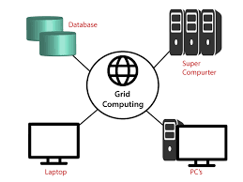

### ****Applications of Hypervisor Virtualization in Enterprises****

Hypervisor virtualization has become a cornerstone of modern IT infrastructure in enterprises, offering a range of benefits that streamline operations, reduce costs, and enhance flexibility. Here’s a detailed look at how hypervisor virtualization is applied in enterprise environments:

#### ****1. Server Consolidation****

**Overview:** Server consolidation refers to the practice of reducing the number of physical servers by running multiple virtual machines (VMs) on fewer physical hosts.

This is achieved through virtualization technology, which allows multiple VMs, each with its own operating system and applications, to operate on a single physical server.

**Benefits:**

* **Cost Reduction:** Decreases the need for physical hardware, leading to lower capital expenditure on servers and reduced operational costs related to power, cooling, and physical space.
* **Efficient Resource Utilization:** Optimizes the use of server resources (CPU, memory, storage) by allowing better allocation and usage compared to traditional single-application servers.
* **Simplified Management:** Reduces the complexity of managing numerous physical servers, making system administration and monitoring more straightforward.

**Implementation Example:** An enterprise with multiple underutilized servers might consolidate these servers into a few high-performance physical machines. By running VMs for different applications or departments on these machines, the enterprise can maximize hardware usage and lower overall infrastructure costs.

#### ****2. Development and Testing Environments****

**Overview:** Virtualization provides isolated environments that can be easily created, modified, and destroyed. This is particularly useful for development and testing purposes, where different configurations and versions of applications need to be tested without impacting production systems.

**Benefits:**

* **Isolation:** Developers and testers can work in environments that replicate production conditions without risking the stability of the live environment.
* **Cost Efficiency:** Enables the creation of multiple test environments on a single physical server, reducing hardware costs.
* **Flexibility:** Allows for rapid deployment and teardown of test environments, making it easier to test various scenarios and configurations.

**Implementation Example:** A software development team might use VMs to create various configurations of their application for testing purposes. They can quickly spin up VMs with different operating systems or application versions, conduct their tests, and then decommission the VMs once testing is complete.

#### ****3. Disaster Recovery and Business Continuity****

**Overview:** Disaster recovery (DR) and business continuity plans benefit greatly from virtualization. Virtualization simplifies the replication and restoration of IT systems in the event of a disaster, ensuring minimal downtime and quick recovery.

**Benefits:**

* **VM Snapshots and Cloning:** Enables the creation of snapshots and clones of VMs, which can be used to restore systems to a previous state in case of failure.
* **Geographic Flexibility:** Allows replication of VMs to offsite locations, ensuring that backup systems are available even if the primary data center is compromised.
* **Rapid Recovery:** Facilitates quick recovery by allowing VMs to be moved or copied to alternative hardware in case of system failure.

**Implementation Example:** An enterprise might implement a DR solution where critical applications are virtualized and replicated to a secondary data center. In the event of a failure at the primary site, the VMs can be quickly activated at the secondary site, minimizing downtime and maintaining business operations.

#### ****4. Desktop Virtualization****

**Overview:** Desktop virtualization involves running desktop operating systems and applications on centralized servers rather than on individual user devices. Users access their desktops remotely through thin clients or other devices.

**Benefits:**

* **Centralized Management:** Simplifies the management and updating of desktop environments, as changes can be made on the server and propagated to all users.
* **Security:** Enhances security by keeping data centralized and reducing the risk of data loss or theft on individual devices.
* **Flexibility and Mobility:** Allows users to access their desktop environments from various locations and devices, supporting remote work and flexible working arrangements.

**Implementation Example:** An organization might deploy virtual desktop infrastructure (VDI) where employees use thin clients or personal devices to connect to virtual desktops hosted on central servers. This setup allows for easy updates, improved security, and consistent user experiences across different locations.

#### ****5. Server and Application Isolation****

**Overview:** Virtualization provides isolation between different applications or services running on the same physical server. This isolation helps in managing dependencies and conflicts between applications and enhances security by compartmentalizing processes.

**Benefits:**

* **Improved Security:** Isolates applications and services, reducing the risk of one application affecting the stability or security of another.
* **Resource Management:** Allocates resources (CPU, memory) to each VM based on application needs, preventing resource contention and performance issues.
* **Conflict Resolution:** Minimizes compatibility issues between different applications or services by running them in separate virtual environments.

**Implementation Example:** An enterprise might run different business-critical applications (e.g., email servers, databases, web applications) in separate VMs on a single physical server. This setup ensures that if one application encounters issues, it does not impact the others, and performance can be tuned individually for each application.

#### ****6. Scalability and Flexibility****

**Overview:** Virtualization provides scalability and flexibility in managing IT resources, allowing enterprises to adjust their infrastructure based on changing demands.

**Benefits:**

* **Dynamic Scaling:** Resources can be scaled up or down based on workload requirements, allowing enterprises to respond quickly to changes in demand.
* **Resource Pooling:** Pools resources from multiple physical servers to provide a flexible and scalable environment.
* **Cost Efficiency:** Reduces the need for over-provisioning and enables more efficient use of resources.

**Implementation Example:** An e-commerce company experiencing high traffic during peak seasons can use virtualization to quickly scale their infrastructure by adding additional VMs to handle the increased load. Once the peak period ends, resources can be scaled back down to save costs.

#### ****7. Testing and Validation of New Technologies****

**Overview:** Virtualization allows enterprises to test new technologies and configurations in isolated environments before deploying them in production.

**Benefits:**

* **Risk Mitigation:** Tests new technologies without impacting existing systems, reducing the risk of disruptions.
* **Cost Savings:** Avoids the need for additional physical hardware for testing purposes.
* **Accelerated Innovation:** Facilitates rapid experimentation with new tools and configurations.

**Implementation Example:** A company exploring a new database management system can deploy it in a virtual environment to evaluate its performance and compatibility with existing applications. If successful, they can then consider a full-scale deployment in the production environment.

### ****High-Performance Computing (HPC) and Virtualization****

High-Performance Computing (HPC) involves using supercomputers or clusters of computers to solve complex computational problems that require substantial processing power. These problems often arise in scientific research, engineering simulations, financial modeling, and other fields that need massive computational resources. Virtualization in HPC can provide numerous benefits, but it also poses certain challenges that need to be addressed to fully leverage its advantages.

#### ****1. Benefits of Virtualization in HPC****

**1.1 Improved Resource Utilization:** Virtualization allows multiple virtual machines (VMs) to share the same physical resources. In HPC environments, this means that the computational power of a cluster can be more efficiently used by running multiple virtual instances on each physical node. This helps in maximizing the utilization of expensive HPC hardware.

**1.2 Flexibility and Scalability:** Virtualization provides the ability to quickly provision and de-provision VMs based on workload demands. For HPC applications, this means that resources can be dynamically allocated as needed. When a particular simulation or computation requires additional resources, VMs can be spun up to meet the demand. Conversely, when the workload decreases, resources can be scaled back to avoid waste.

**1.3 Simplified Management:** Managing a large number of physical servers can be complex and resource-intensive. Virtualization abstracts the underlying hardware, making it easier to manage and maintain computing resources. Tasks such as provisioning, monitoring, and maintaining systems can be streamlined through virtualization management tools, reducing administrative overhead.

**1.4 Isolation and Fault Tolerance:** Virtualization provides isolation between different VMs, which can be advantageous in an HPC environment. It ensures that if one VM experiences a failure or issues, other VMs can continue to operate without disruption. This isolation also helps in testing and development, allowing new software or configurations to be tested in a controlled environment without affecting production workloads.

**1.5 Cost Efficiency:** By consolidating multiple workloads onto fewer physical servers, virtualization can reduce hardware costs. This is particularly beneficial in HPC environments where hardware is often expensive. Virtualization allows organizations to leverage their hardware investments more effectively and reduce overall infrastructure costs.

#### ****2. Challenges and Considerations****

**2.1 Performance Overhead:** One of the primary concerns with virtualization in HPC is the performance overhead introduced by the hypervisor. Virtualization adds an additional layer between the hardware and the application, which can lead to performance degradation compared to running directly on physical hardware. This overhead can be significant in HPC applications where performance is critical.

**2.2 Resource Contention:** In a virtualized HPC environment, multiple VMs sharing the same physical resources can lead to resource contention. Proper management and allocation of resources are essential to ensure that high-priority applications receive the necessary computational power. Virtualization solutions must be carefully configured to balance workloads and prevent performance bottlenecks.

**2.3 Compatibility and Support:** Not all HPC applications are well-suited for virtualization. Some applications may require direct access to hardware features or have specific performance requirements that are difficult to meet in a virtualized environment. It's important to evaluate the compatibility of HPC applications with virtualization and ensure that they can operate effectively within virtual machines.

**2.4 Complexity in Management:** While virtualization can simplify management in some respects, it also introduces additional complexity. Managing a virtualized HPC environment requires expertise in both virtualization technology and HPC workloads. This includes understanding how to configure and optimize the hypervisor, as well as how to manage resource allocation and performance tuning.

**2.5 Security Considerations:** Virtualization introduces new security challenges, such as the potential for vulnerabilities in the hypervisor that could affect multiple VMs. Ensuring that the hypervisor is secure and properly configured is crucial to maintaining the security of the entire HPC environment. Additionally, proper isolation between VMs is necessary to prevent unauthorized access to sensitive data or applications.

#### ****3. Best Practices for Virtualizing HPC Environments****

**3.1 Performance Optimization:** To minimize performance overhead, choose hypervisors and virtualization technologies that are optimized for HPC workloads. Look for features such as hardware acceleration and resource management tools that can help mitigate performance impacts.

**3.2 Resource Allocation and Management:** Implement resource allocation strategies to ensure that critical applications receive the necessary resources. Use virtualization management tools to monitor resource usage and dynamically adjust allocations based on workload demands.

**3.3 Compatibility Testing:** Thoroughly test HPC applications in a virtualized environment before full deployment. Assess how well applications perform in virtual machines and make any necessary adjustments to ensure compatibility and performance.

**3.4 Security Practices:** Adopt robust security practices to protect the virtualized HPC environment. This includes keeping the hypervisor up-to-date with security patches, using strong access controls, and regularly auditing the virtual environment for potential vulnerabilities.

**3.5 Training and Expertise:** Ensure that IT staff have the necessary expertise in both virtualization and HPC to manage and optimize the environment effectively. Investing in training and professional development can help address the complexities of managing virtualized HPC infrastructure.

### ****Pitfalls of Virtualization****

Despite its advantages, virtualization comes with certain challenges. Performance overhead is a significant concern, as the additional layer of abstraction introduced by the hypervisor can lead to reduced efficiency compared to direct hardware access. The complexity of managing virtual environments also requires specialized skills and tools to ensure effective operation and maintenance. Additionally, security risks are amplified in virtualized environments, where multiple VMs share the same physical host. This scenario necessitates robust security measures to prevent potential vulnerabilities and attacks that could affect multiple virtual instances.

### ****1. Performance Overhead****

* **Issue:** Additional layer (hypervisor) between hardware and VMs can cause performance degradation.
* **Impact:** Reduced efficiency and increased latency.
* **Mitigation:** Use high-performance hypervisors, leverage hardware-assisted virtualization, and monitor performance regularly.

### ****2. Resource Contention and Overcommitment****

* **Issue:** Multiple VMs sharing the same physical resources can lead to contention and overcommitment.
* **Impact:** Performance degradation and unpredictable behavior.
* **Mitigation:** Implement resource management policies, monitor utilization, and conduct capacity planning.

### ****3. Security Concerns****

* **Issue:** Hypervisor vulnerabilities and potential data isolation issues between VMs.
* **Impact:** Risk of data breaches and unauthorized access.
* **Mitigation:** Harden the hypervisor, ensure strong VM isolation, and conduct regular security audits.

# ****4. Complexity in Management****

* **Issue:** Increased complexity due to the interplay between virtual and physical infrastructure.
* **Impact:** Higher administrative overhead and troubleshooting difficulties.
* **Mitigation:** Use comprehensive management tools, standardize configurations, and invest in staff training.

### ****5. Data Backup and Recovery Challenges****

* **Issue:** Virtualized environments complicate traditional backup and recovery processes.
* **Impact:** Complexity in backups and potentially longer recovery times.
* **Mitigation:** Use virtualization-aware backup solutions, regularly test backups, and automate backup processes.

### ****6. Vendor Lock-In****

* **Issue:** Proprietary technologies and tools can lead to dependency on a single vendor.
* **Impact:** Challenges in migrating workloads and reduced flexibility.
* **Mitigation:** Adopt open standards, plan for portability, and evaluate vendor options carefully.

### ****Multitenant Software: Multi-Entity Support****

Multitenant software is designed to serve multiple customers or tenants from a single software instance while maintaining data and configuration isolation. This model allows each tenant to operate in a shared environment without interfering with other tenants' data or operations. Multi-entity support in such software ensures that different organizations or users can customize their experiences while leveraging a common application framework. This approach is particularly advantageous for SaaS (Software as a Service) applications, where cost-efficiency and scalability are key.

**Definition:** Multitenancy allows multiple clients (tenants) to use the same software instance while keeping their data and configurations isolated.

**Key Aspects:**

1. **Data Isolation:**
   * **Purpose:** Ensures each tenant's data is separate and secure.
   * **Method:** Uses separate schemas or tables in the database.
2. **Configuration Isolation:**
   * **Purpose:** Allows each tenant to have custom settings and preferences.
   * **Method:** Manages through tenant-specific configuration settings.
3. **Access Control:**
   * **Purpose:** Restricts data and functionality access based on tenant identity.
   * **Method:** Implements role-based or attribute-based access controls.
4. **Resource Allocation:**
   * **Purpose:** Ensures fair distribution of computing resources among tenants.
   * **Method:** Employs resource quotas and load balancing.

**Implementation Strategies:**

* **Data Management:** Use encryption and database partitioning.
* **Customization:** Allow tenant-specific settings and feature toggles.
* **Security:** Implement strong access controls and regular audits.
* **Scalability:** Use dynamic scaling and performance monitoring.

**Challenges:**

* **Management Complexity:** Handling multiple tenant configurations.
* **Data Security:** Keeping data isolated and secure.
* **Performance Balance:** Preventing one tenant’s usage from affecting others.
* **Compliance:** Meeting varied regulatory requirements.

Multitenant software efficiently serves multiple clients by ensuring data isolation, customizable configurations, and secure, fair resource allocation.

### ****Multi-Schema Approach****

**Multi-Schema Approach:** In a multi-schema approach, each tenant's data is stored in a separate schema within the same database. A schema is a logical container that holds database objects such as tables, views, and procedures.

### ****Benefits****

1. **Data Isolation:**
   * **Purpose:** Ensures that data from different tenants is kept separate, providing security and privacy.
   * **Method:** Each tenant’s data resides in its own schema, preventing accidental access or leakage.
2. **Simplified Management:**
   * **Purpose:** Easier to manage and maintain data structures for each tenant.
   * **Method:** Admins can handle backups, updates, and schema changes on a per-schema basis.
3. **Customizability:**
   * **Purpose:** Allows customization of database objects and structures per tenant.
   * **Method:** Schema-specific customizations can be implemented without affecting other tenants.
4. **Performance Optimization:**
   * **Purpose:** Helps optimize performance by isolating data access patterns.
   * **Method:** Database queries and operations are scoped to a specific schema, reducing the risk of performance bottlenecks caused by inter-tenant data.

### ****Implementation****

1. **Schema Design:**
   * **Structure:** Design separate schemas for each tenant within the same database.
   * **Objects:** Define tables, indexes, and other database objects within each schema.
2. **Access Control:**
   * **Security:** Implement access controls to ensure that users can only access their respective schemas.
   * **Authentication:** Use tenant-specific authentication mechanisms to enforce access restrictions.
3. **Backup and Recovery:**
   * **Backup:** Perform backups at the schema level to isolate tenant data and simplify recovery processes.
   * **Recovery:** Restore specific schemas as needed without affecting others.

### ****Challenges****

1. **Schema Management:**
   * **Issue:** Managing a large number of schemas can be complex and resource-intensive.
   * **Solution:** Use automation and management tools to handle schema creation and maintenance.
2. **Performance Considerations:**
   * **Issue:** Performance can be impacted if the database becomes too large or if schemas are not properly optimized.
   * **Solution:** Monitor performance and optimize schemas and indexes to ensure efficient data access.
3. **Scalability:**
   * **Issue:** As the number of tenants grows, managing many schemas may become challenging.
   * **Solution:** Plan for scalability with efficient schema management practices and consider database partitioning or sharding if needed.
4. **Data Migration:**
   * **Issue:** Migrating data between schemas or between different environments can be complex.
   * **Solution:** Develop a robust data migration strategy and use tools to automate and streamline the process.